State Highpoint Data Visualization

Process Book

**By Jonathan Himes and Jesus Hurtado**

**Project Repository**

<https://github.com/HeyZeus02/DataVizProject2022>

# Background and Motivation

Many outdoor enthusiasts and climbing communities have a goal of visiting the highest point of elevation in each of the 50 states of the US. Some highpoints, such as the Black Mesa highpoint in Oklahoma, are easy hikes. Other highpoints, such as Mount Rainier in Washington, can be a multiday mountaineering expedition. Various clubs, groups, and message boards have been created to discuss and share experiences in this pursuit.

A limitation in communicating these experiences is access to a way to present the data. It has been observed, by at least one team member, that individuals with access and proficiency in ESRI’s GIS software are able to garner a lot of interest from both outdoor and non-outdoor enthusiasts. This software is expensive, however, and most users require significant schooling to learn to use the software.

The ability to effectively communicate your trip experience is rewarding in and of itself. The rise and popularity of social media platforms is testament to the fact that people like to share their accomplishments and interests. Being able to visualize visit experiences also generates interest in people who have never done anything like this before. This can lead to more enthusiasm for being outdoors. More enthusiasm in the outdoors can lead to more concern for the conservation of the environment and our outdoor spaces.

# Project Overview

The objective of this project is to develop a simple, easy to use website that provides users unskilled in data visualization or lacking access to visualization software the ability to generate custom visualizations that can be used to communicate their progress in visiting the highpoints in each state.

The users would input basic information such as which state highpoints they have visited and the date of their visit. The website would take this data and other data not provided by the user and generate a set of visualizations. The user can then download and share these high-quality visualizations summarizing their experiences.

The user will also be able to explore basic information about the US peaks on the landing page such as location in the United States and a bar chart comparing their elevations.

# Related Work

* [https://www.peakbagger.com/ListIndx.aspx?cid=0&unit=m#1](https://www.peakbagger.com/ListIndx.aspx?cid=0&unit=m%231) – This site provides data for various highpoints around the world in tabular format and has a map but does not go any further in visualizing the data.
* The AllTrails app creates basic stats about hikes but is not tailored to just highpoints. Graphical user interface, application

  Description automatically generated
* This is a page of a map journal done by a friend showing cumulative flights. We want to apply this to highpoints.Map

  Description automatically generated

# Questions

* What are the highest peaks in each US state?
* Where are they located at in relation to each other?
* What are their elevations?
* How do their elevations relate to each other?
* How many peaks has the user visited?
* What is the total elevation the user climbed in visiting the peaks?
* What percentage of peaks has the user climbed?
* What percentage of peaks has the user not climbed?
* What is a summary of the temperatures when the user climbed?
* What year did the user climb the most?
* Can the user share the data about his climbs with others easily?

These questions have not evolved much since the initial proposal. One interesting additional question we came up with is:

* What percentage of the highpoints are within 10 miles of the edge of the state.

# Data

At the current stage of the project, data will be coming from the following sources.

* Geographical Data (Latitude, Longitude, Elevation) <https://en.wikipedia.org/wiki/List_of_U.S._states_and_territories_by_elevation>

[https://www.peakbagger.com/ListIndx.aspx?cid=0&unit=m#1](https://www.peakbagger.com/ListIndx.aspx?cid=0&unit=m%231)

* State GeoJSON file

<https://www.kaggle.com/datasets/pompelmo/usa-states-geojson?resource=download>

* Weather data

NOAA API - <https://www.ncdc.noaa.gov/cdo-web/webservices/v2#gettingStarted>

* User input csv

This will include:

* + Highpoints visited
  + Dates of visits

# Exploratory Data Analysis

We came into the project with a clear understanding of what our raw data included so a lot of exploratory analysis was not required.

We did notice once we had mapped our data an interesting feature that a lot of the highpoints were right on the edge of the states that wasn’t apparent from looking at the tabular data.

# Design Evolution

We started the project with a clear idea that we wanted the website to be broken up into 3 pages separated by tabs.

While working on the project, we thought using mountains as tabs would increase the user experience. These mountains were created by the user and may be replaced by more professionally looking mountains.

Originally, there was going to be a feature to add in notes and user’s hiking experience but we found that this would muddle the overall goal of showing the basic hiking stats.

Color choices are still in flux and will be determined when all functionality is created.

# Implementation

## Landing Page

The goal is to show overall statistics about US highpoints

### Overall Map

Shows the location of each highpoint. More functionality will be added when a hover tooltip displaying the peak, state, and elevation is added.

### Table

Shows a comparison of the elevations and the names of each state in an easy to lookup and sort manner. More functionality will be added to highlight peak that is selected in the map.

## Input Page

Allows user to input data. Formatting and user directions still to be added.

### Input CSV

This is the format of the csv that user downloads, fills out and then uploads

## Output Page

Shows the basic statistics. Additional graphs are still in the works

### Cumulative Time Series

This will show the cumulative elevation that the user has climbed

### Pie chart of mountains climbed and yet to be climbed.

To be done

### Dashboard with numeric statistics such as coldest and hottest temperature, highest point visited so far, cumulative elevation, etc.

To be done

## Bar chart with total elevation climbed per year.

To be done

## The ability for users to export out graphs

To be done

# Evaluation

We have learned that it is possible for a user inexperienced in visualization to create high quality statistical representations of their data by just inputting the dates of their climbs.

# Proposal Design Evolution

The following were proposed during the initial design proposal before any work had occurred on creating the visualization. By the time work had started, Design 3 was chosen.

Design 1: The website is all one scrollable page. This will be easy for the user to navigate. There is a title and below it is a blurb about what high pointing is. Below that there is a map of the US with the high points represented as mountains with their length corresponding to their height. To the right of this map, will be a bar chart with horizontal bars showing the elevations of each highpoint sorted by elevation. Below that are instructions for uploading your data. Below that is a feature to download the csv form and upload it once it has been filled in. Below that, the dashboard is generated. More infographics will be determined but for now there is:

* A cumulative time series of elevation climbed. The x axis is the date, and the y axis is the cumulative elevation. The actual mountains climbed are in color and the mountains yet to be climbed are grayed out. The elevation and corresponding mountain are displayed when hovered on.
* A pie chart of mountains climbed and yet to be climbed.
* The overall map at top changes so visited highpoints turn a different color. The state, highpoint name, date, notes, and weather can be displayed when hovered.
* A small map of the US with arrows going from one highpoint to the next in order that the highpoints were visited.
* A dashboard with numeric statistics such as coldest and hottest temperature, highest point visited so far, cumulative elevation, etc.
* A bar chart with total elevation climbed per year.

Each of these infographics can be exported as a static image.

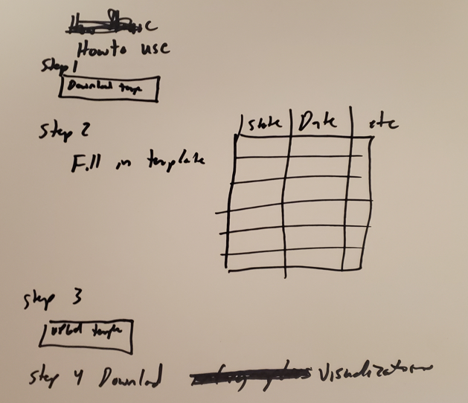

Design 2: This design incorporates all of the above but also includes the option to update which highpoints have been visited through drop down menus instead of a csv.

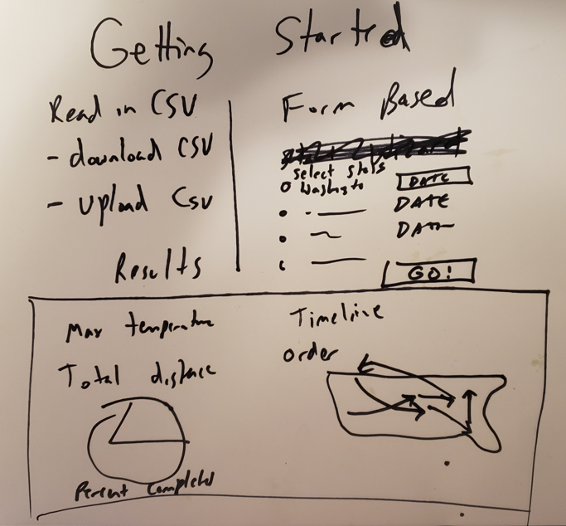

Design 3: Has the same features as the other designs but instead of being one continuous page it has 3 tabs. The first tab is the landing page that has the title, information, and overall map of where the highpoints are located. The second tab is an input tab where you can download and upload the csv or use the input drop down menus to input your visits. The last tab will be the output of all the graphs.

Final Design: Will look very similar Design 3. Special attention will be paid to color scheme to make the website look streamlined. This is most likely going to be the color scheme for the website minus the color #464866 which looks very similar to color #29648A to a person with Green-Blind/Deuteranopia.

